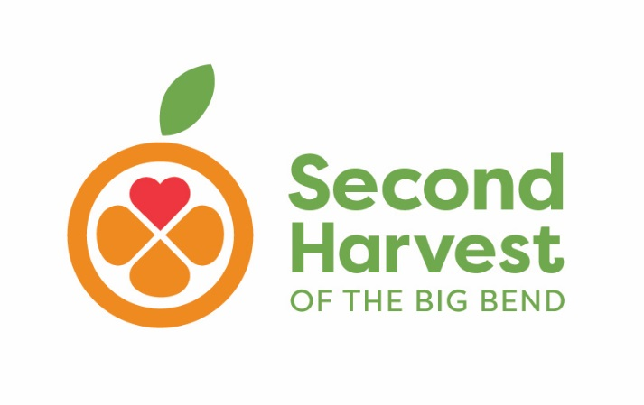

**Backpack Program 2020-2021**

**Permission Form**

Dear Parents/Guardian:

Your child has been chosen to participate in the **Backpack Program** this year.

The **Backpack Program** is a partnership between Second Harvest of the Big Bend and Griffin Middle School. Each Friday, your child will bring home a bag filled with healthy and nutritious food provided by Second Harvest of the Big Bend and given to your child at ­­­­­­­­­­­­­­school by school employees/volunteers. Please know that the school does its best to make sure that no other child knows your child receives this service.

This program will begin this Friday 12/18/2020.

By signing this form, you agree to allow your child to participate in this program, as well as to provide the information requested below.

Child’s Name ___________________________ Child’s Age____________________

I, ________________________, am aware of the Backpack Program and certify that the information I have provided is true and correct.

__________________________________ ________

Signature of Parent/Guardian Date

---------------------------------------------------------------------------------------------------------------

Verbal permission was provided by _____________________________

(parent/guardian) to ___________________________________(school staff member).